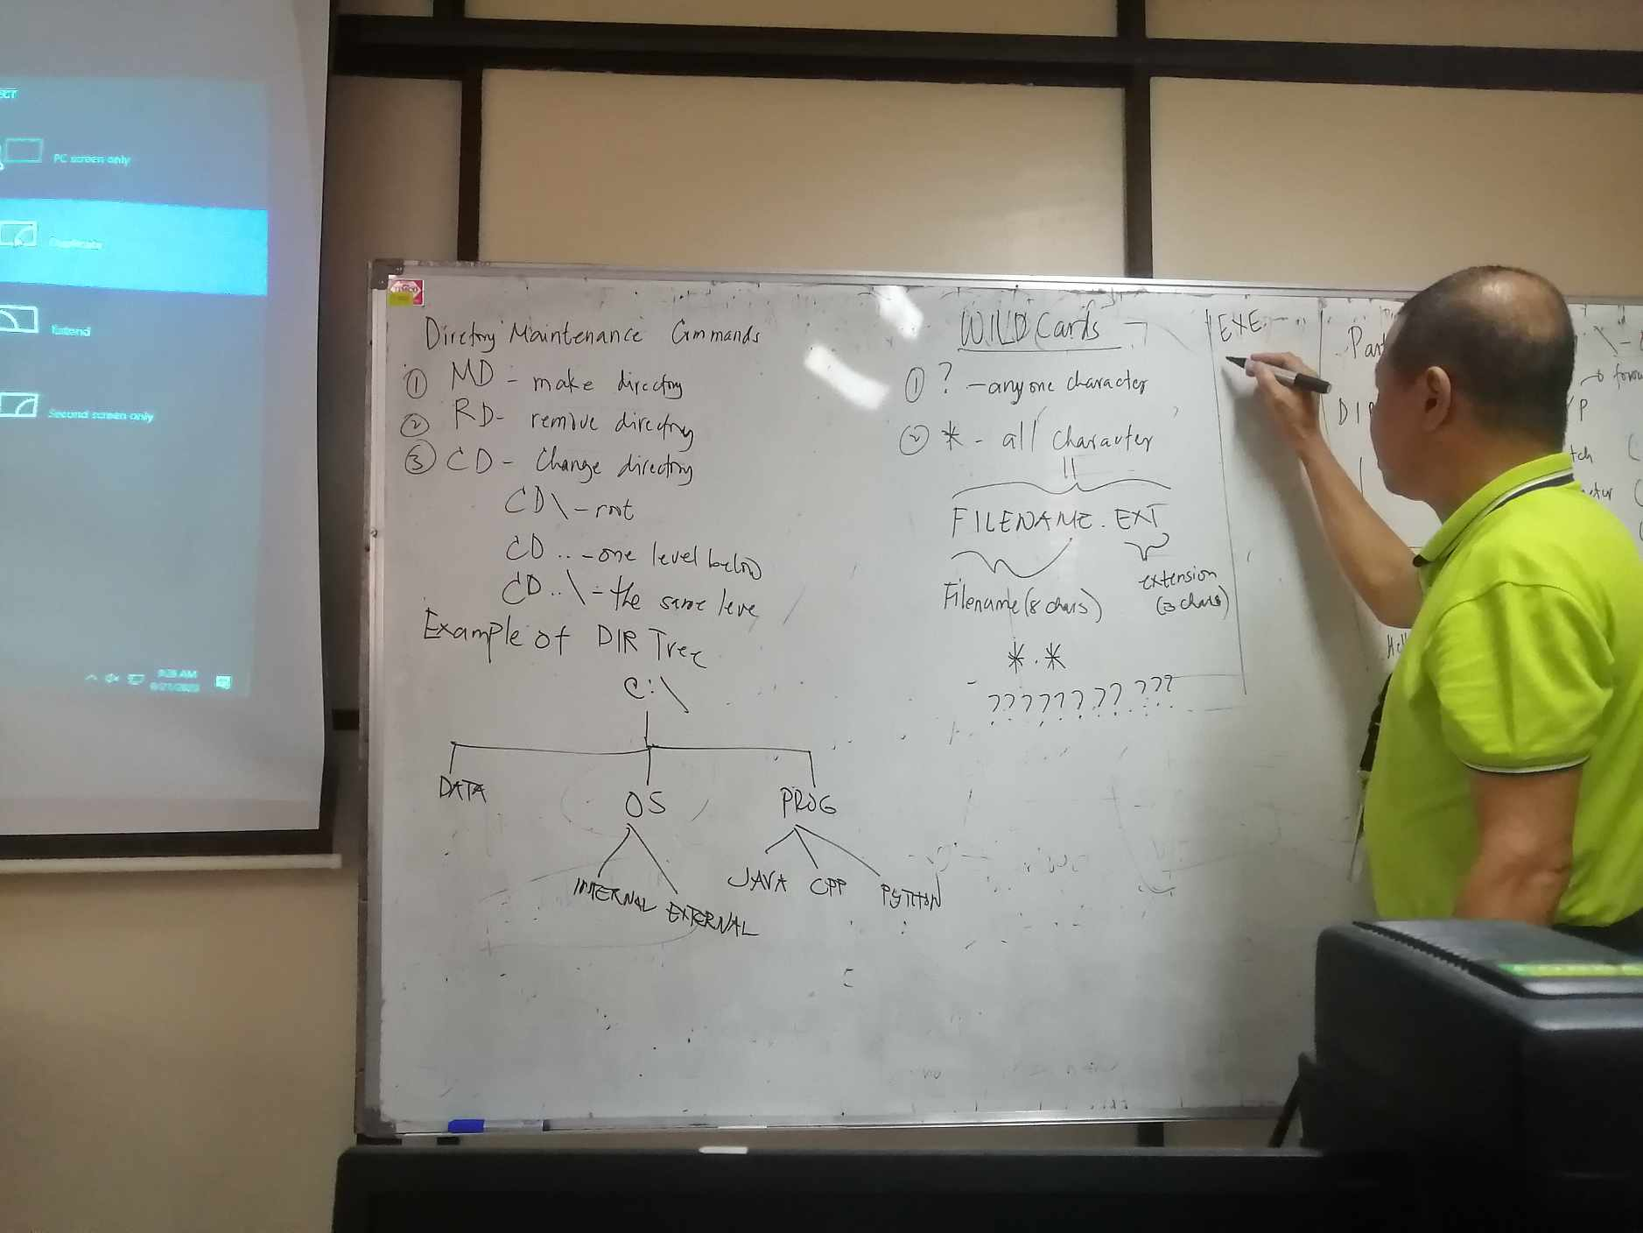

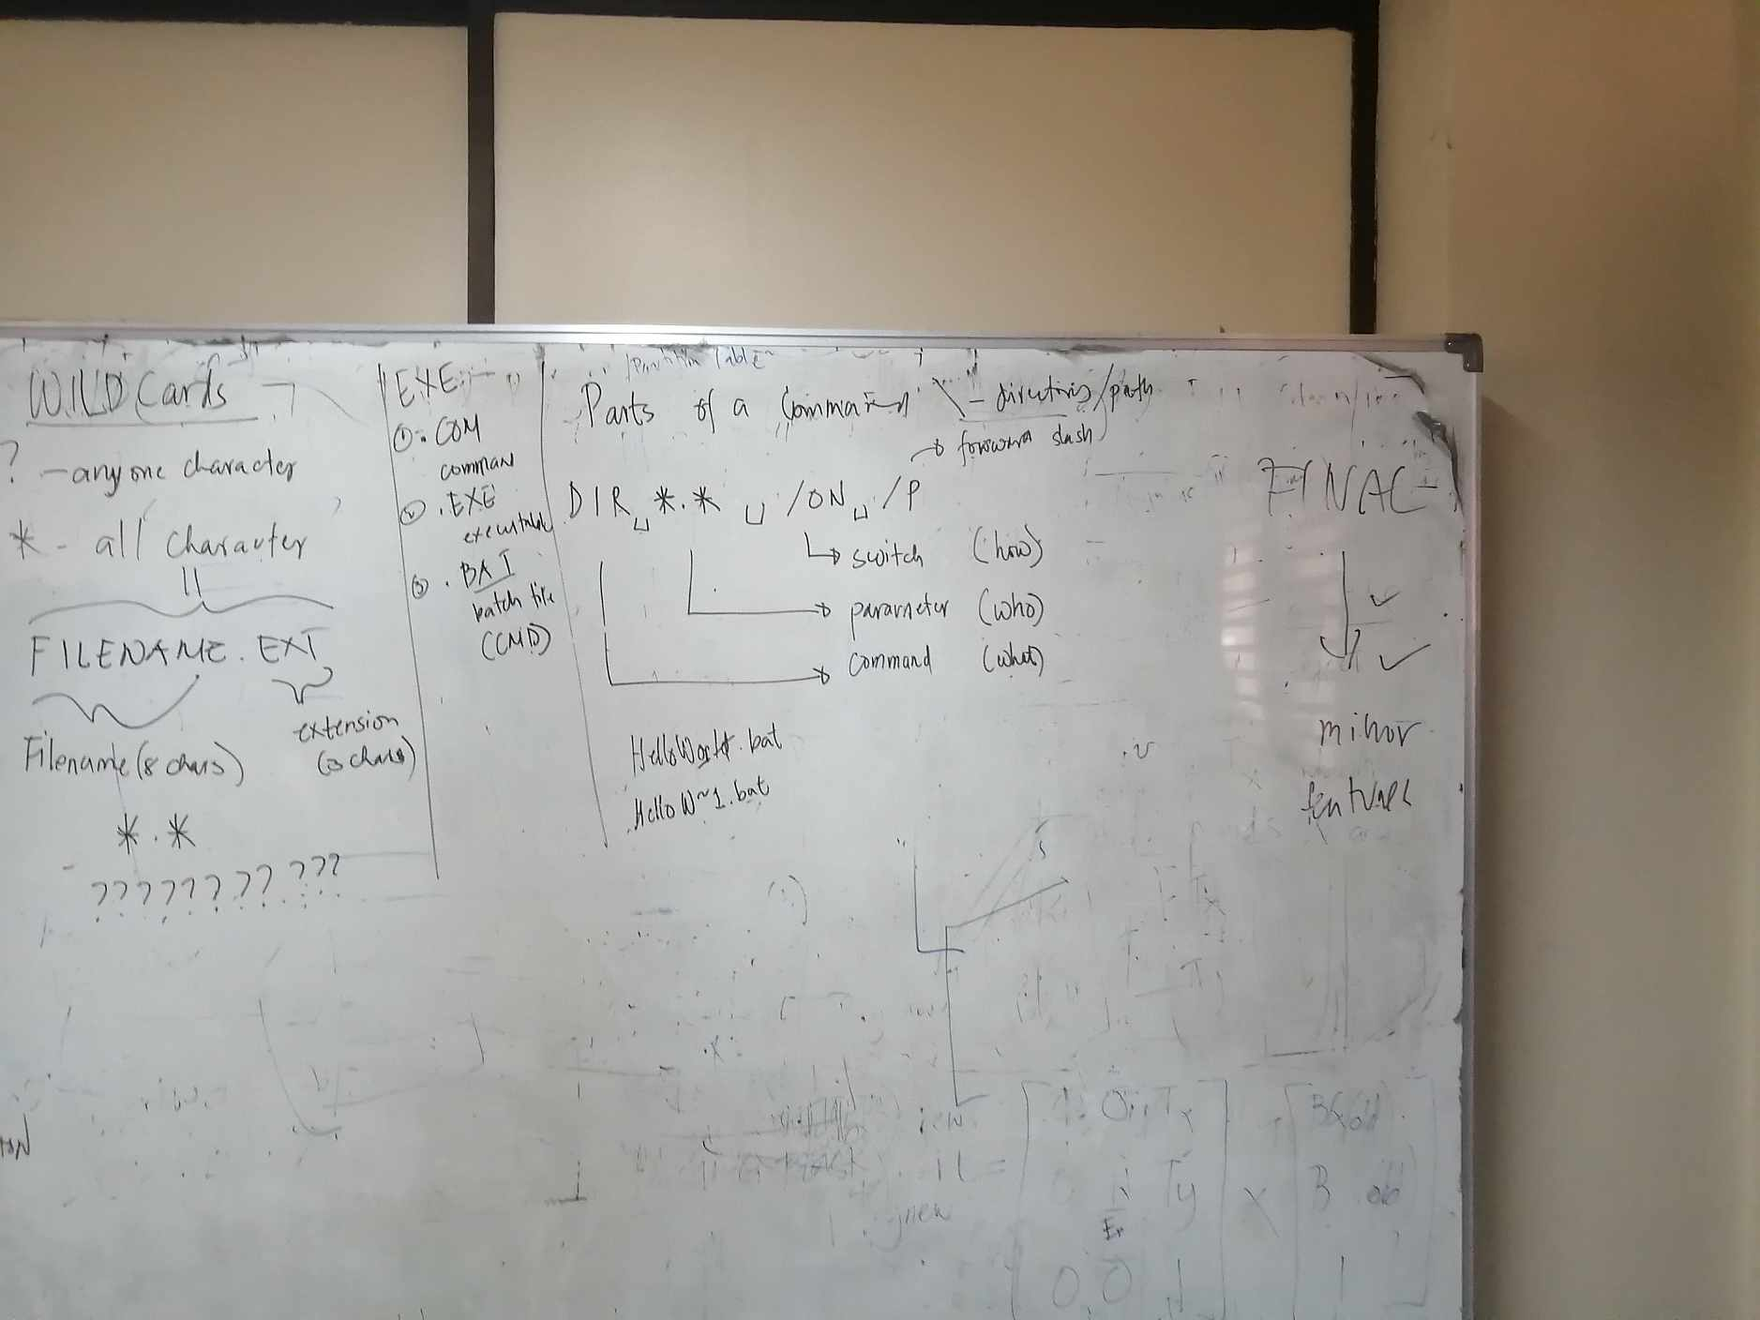

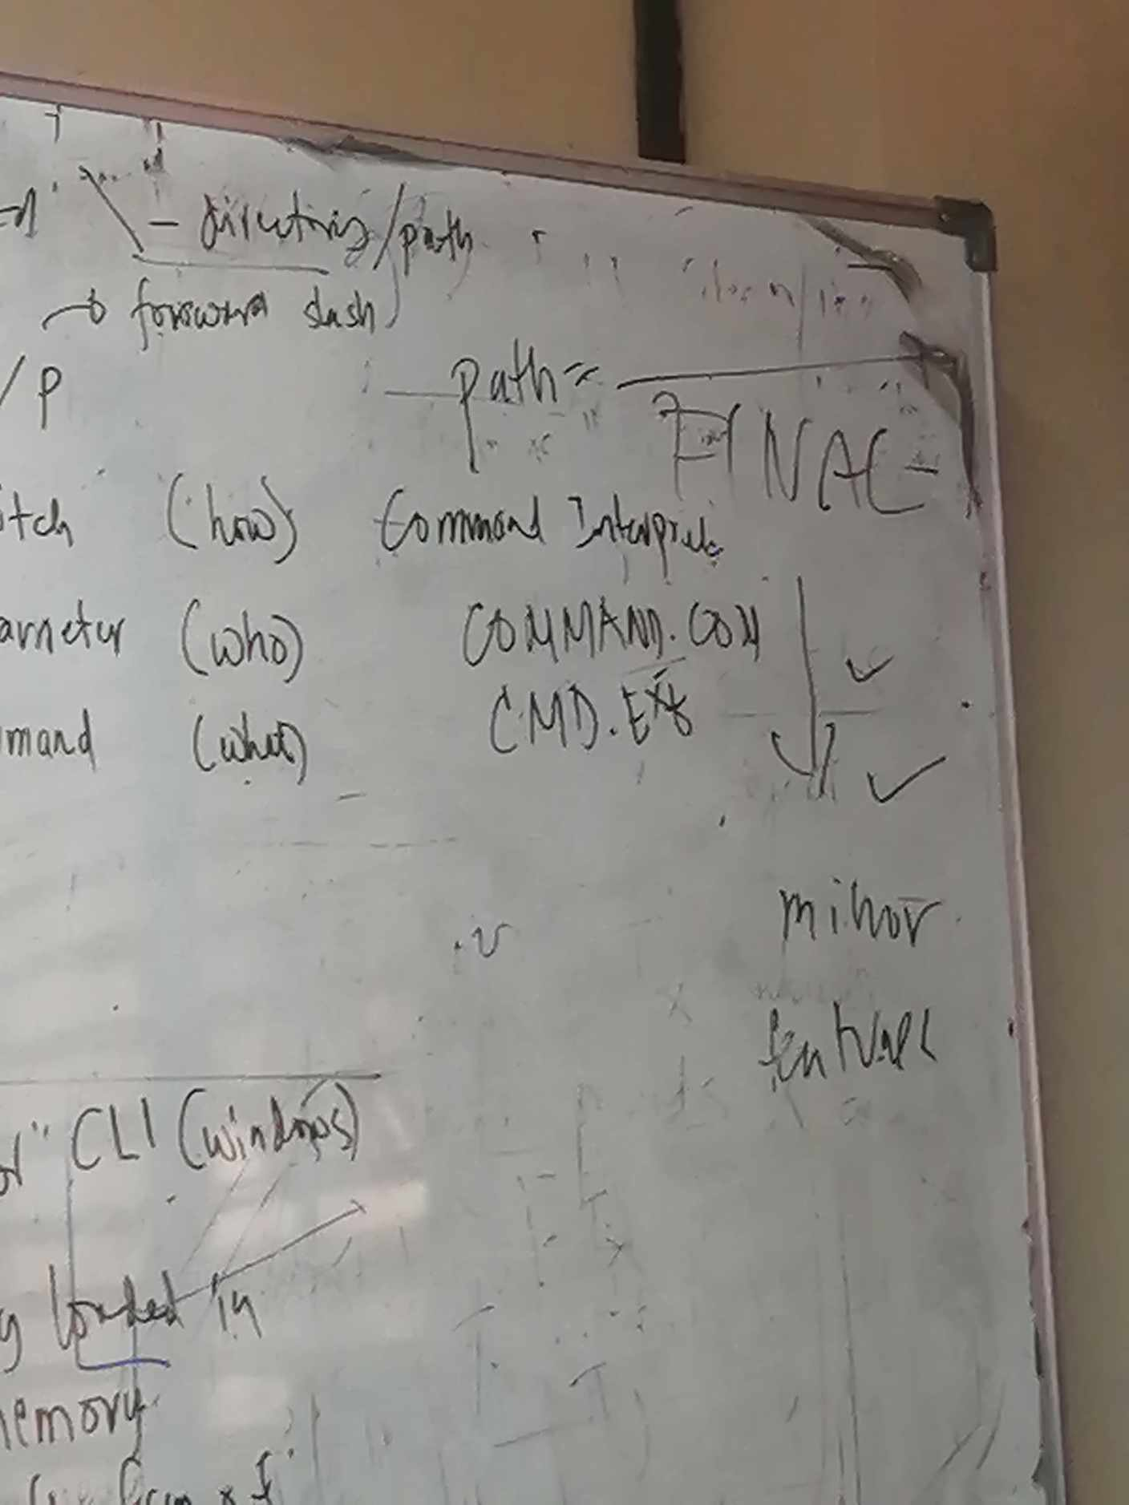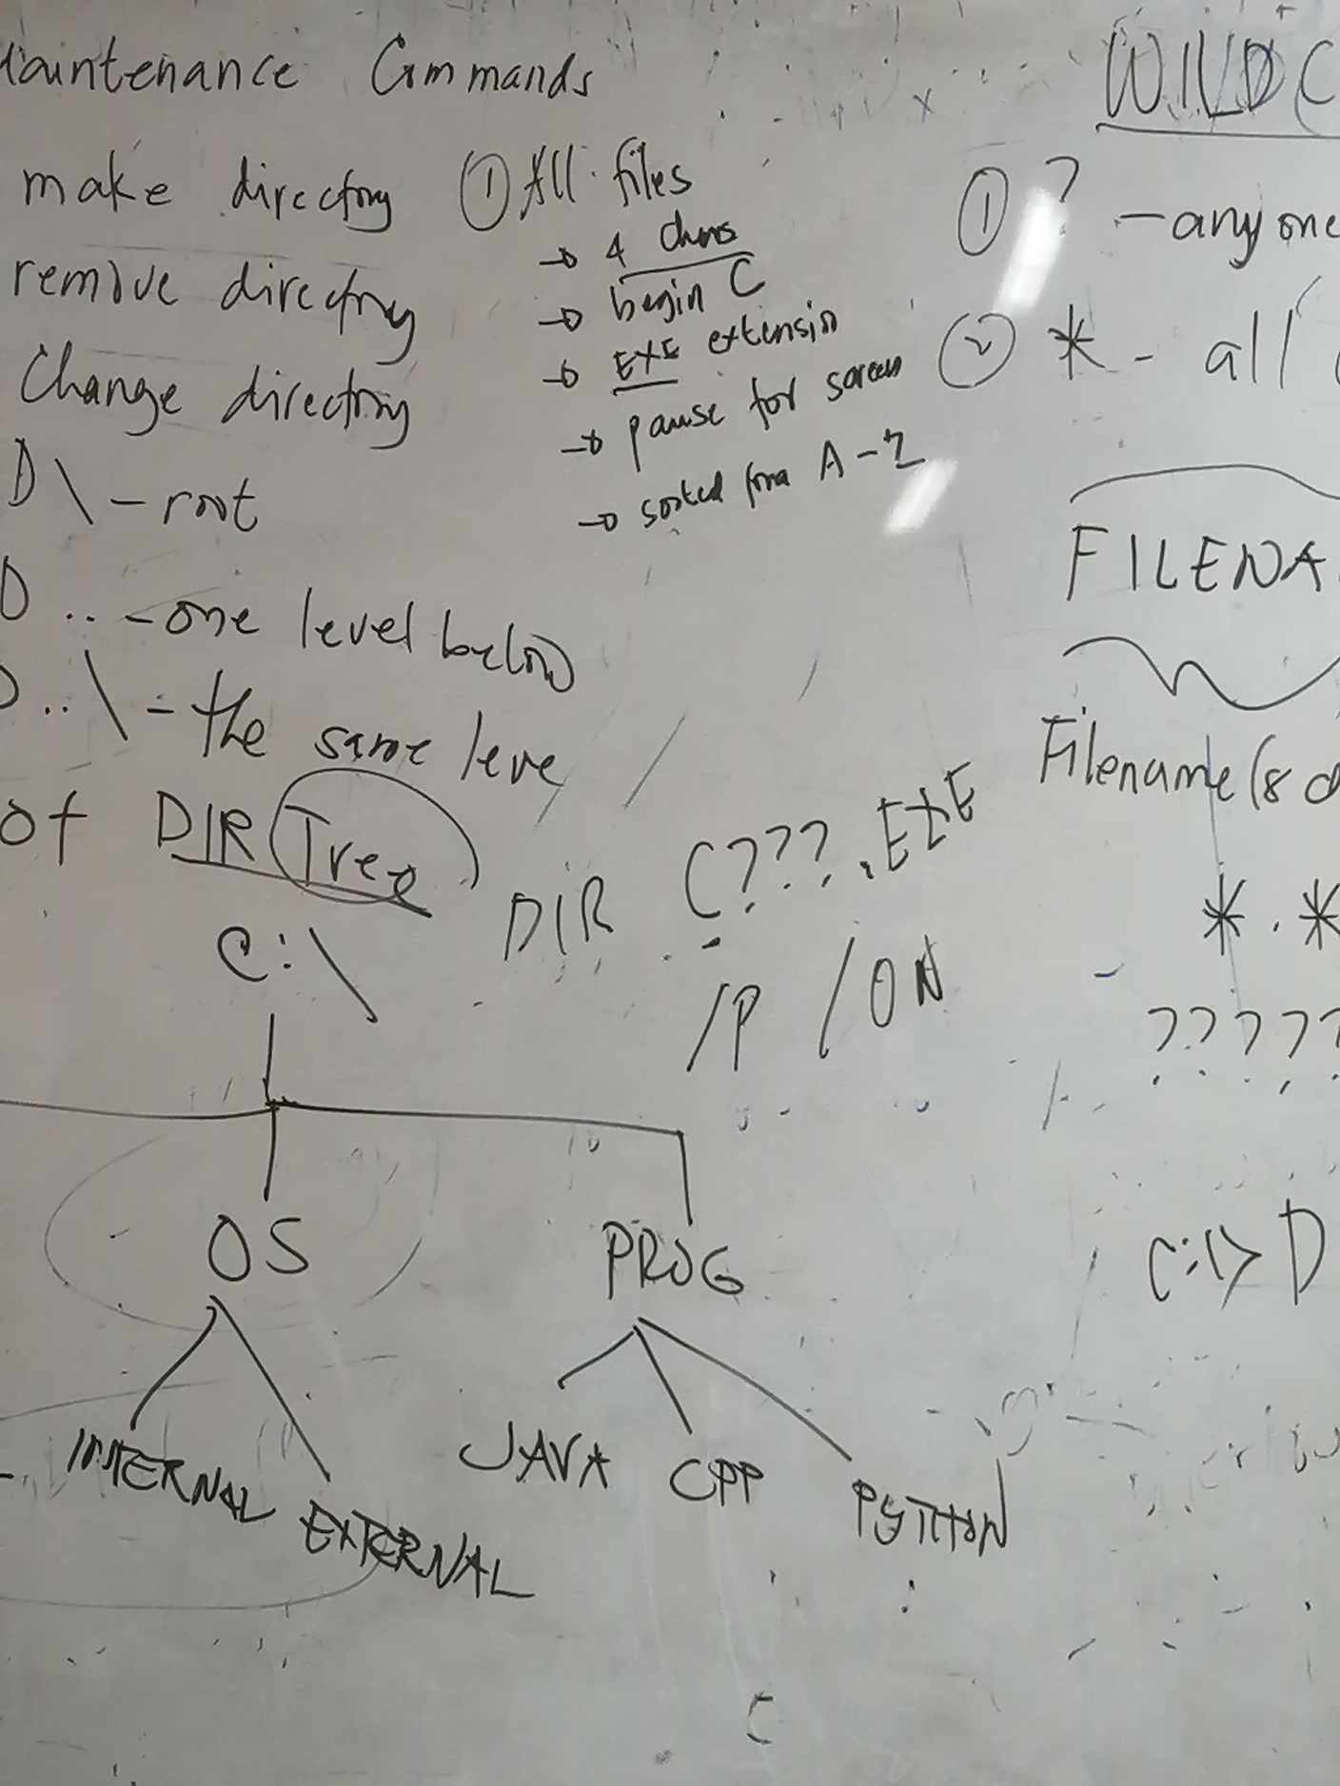

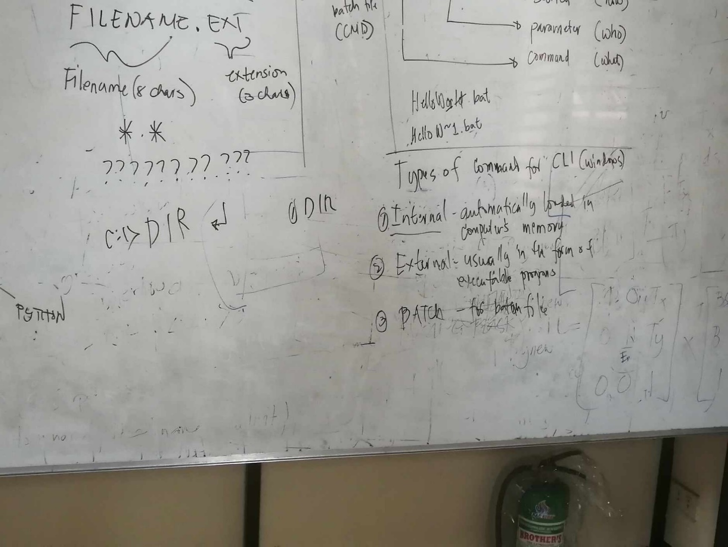

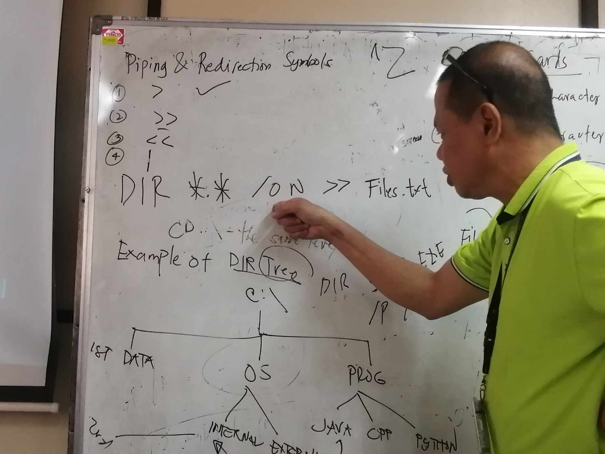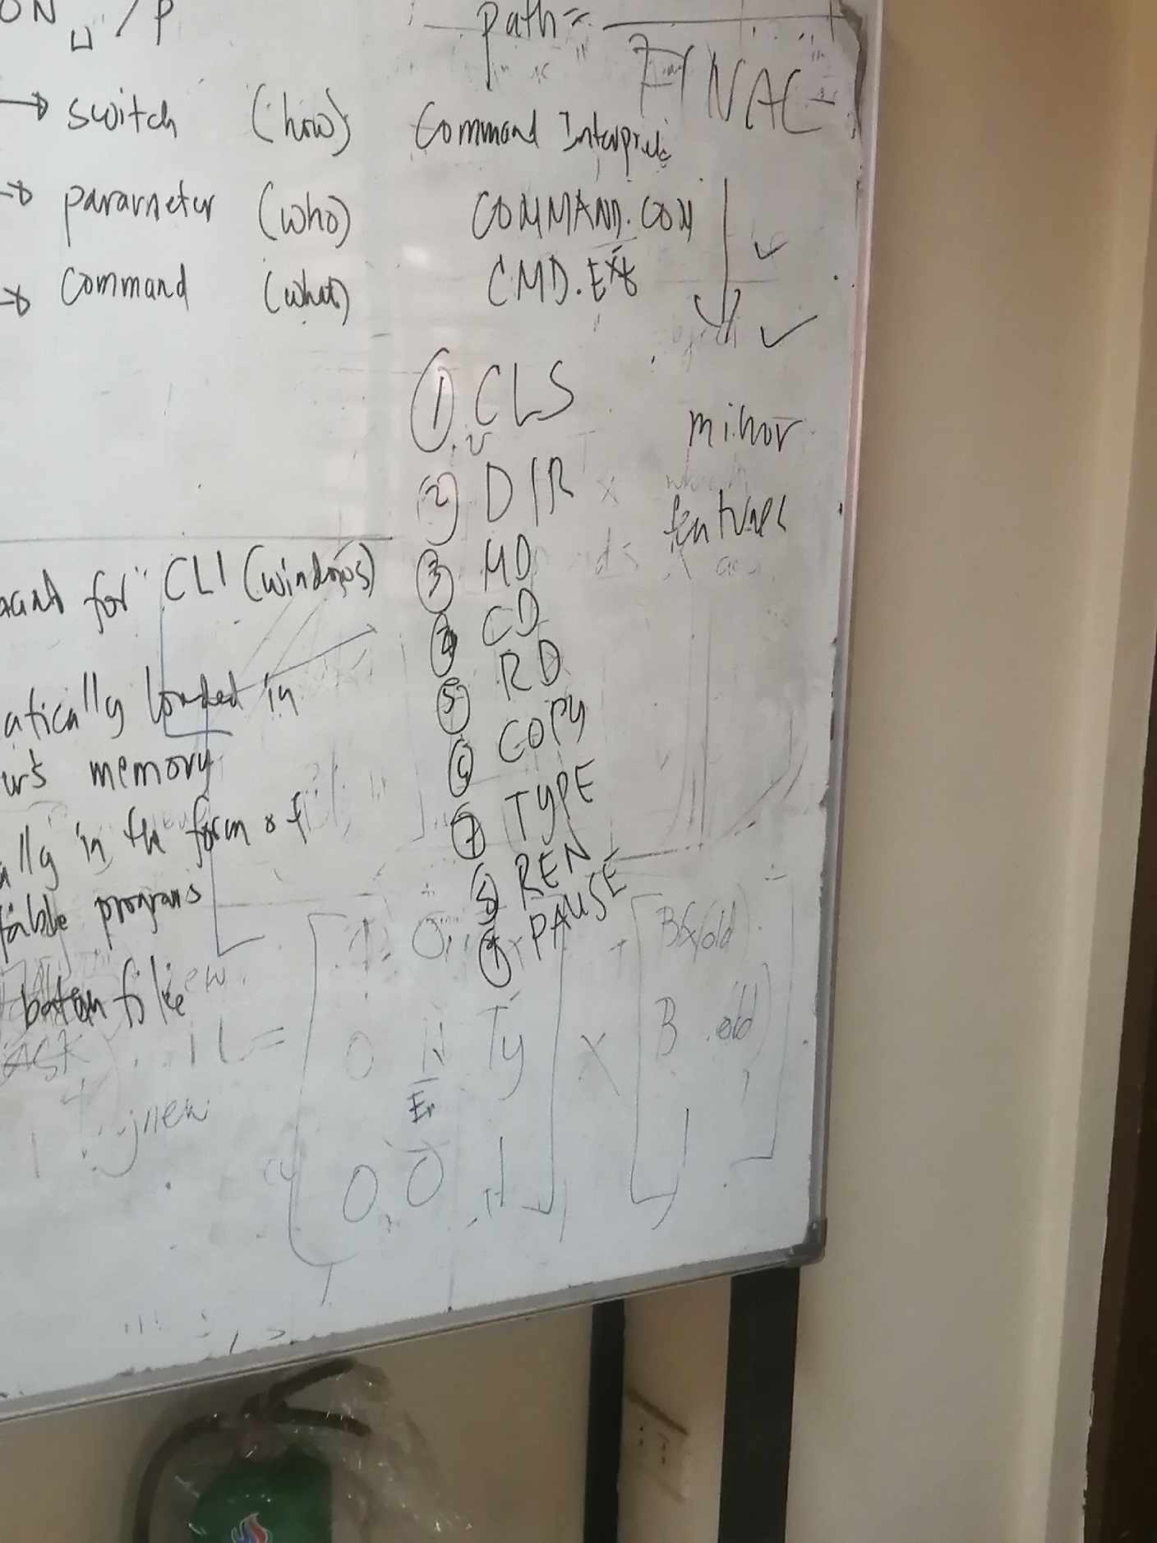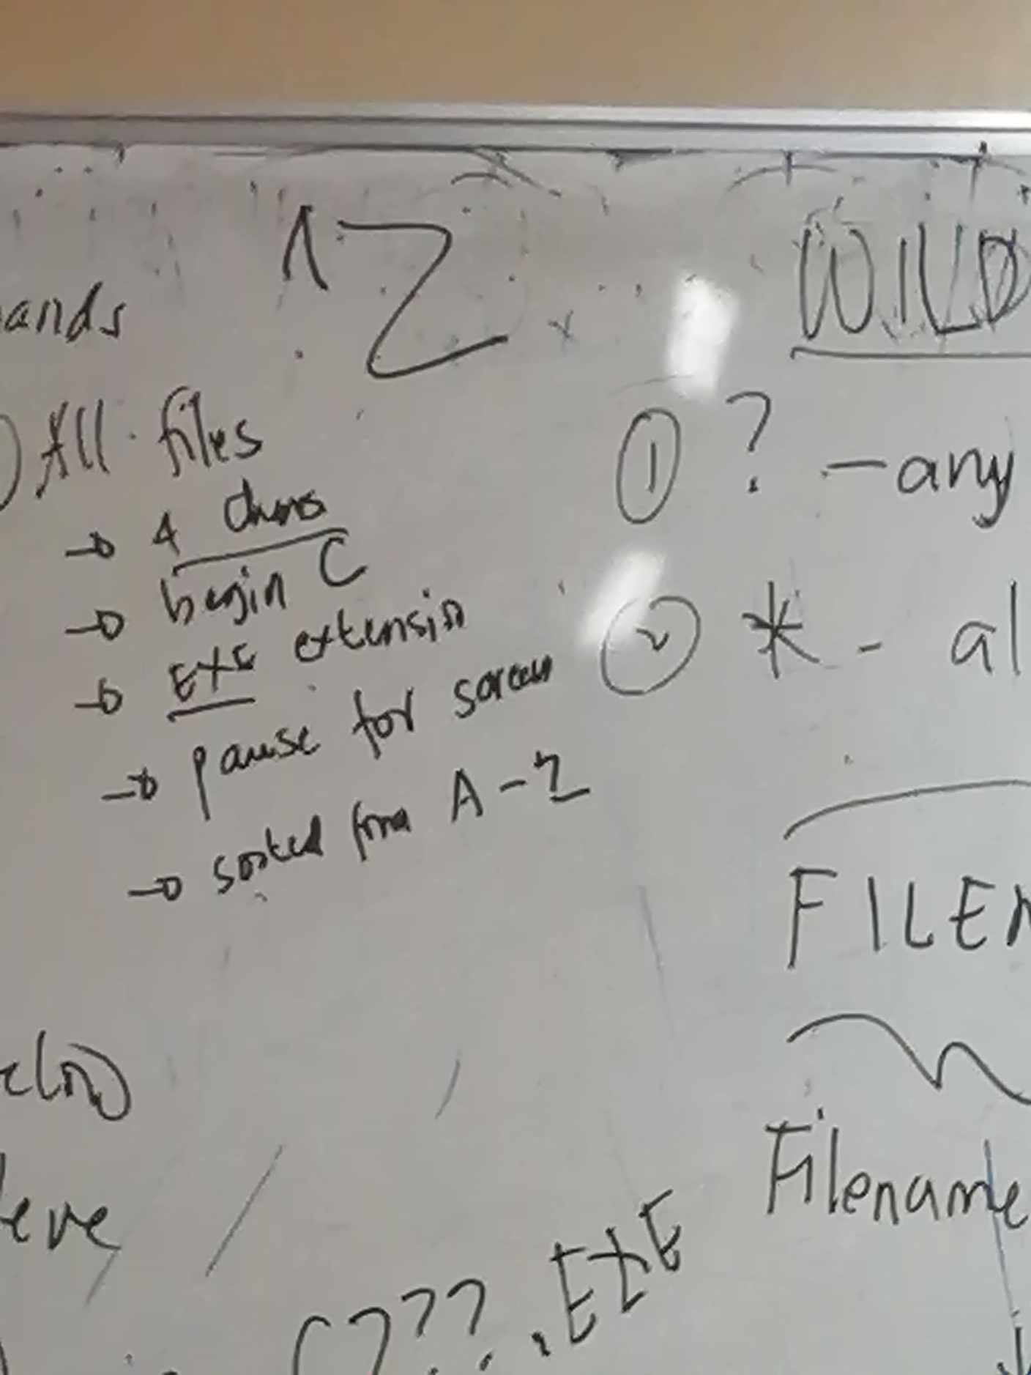

Wildcards

<https://www.youtube.com/watch?v=uoA8sBHV6_c>

**windows cli in one command change directory by going to previous directory then going to next subdirectory**

cd ..\subdirectory_name

go back two directories in the Windows command line interface:

cd \\..

windows cli how to move a file to another folder that is not a subfolder:

move source destination

move my_file.txt C:\Users\User\Desktop

windows cli how to move file back to previous directory

move filename ..\

The copy command has the following syntax:

copy source destination

copy my_file.txt C:\Users\User\Desktop

windows cli command that shows description of all other commands

The Windows command line interface (CLI) command that shows a description of all other commands is help

Question

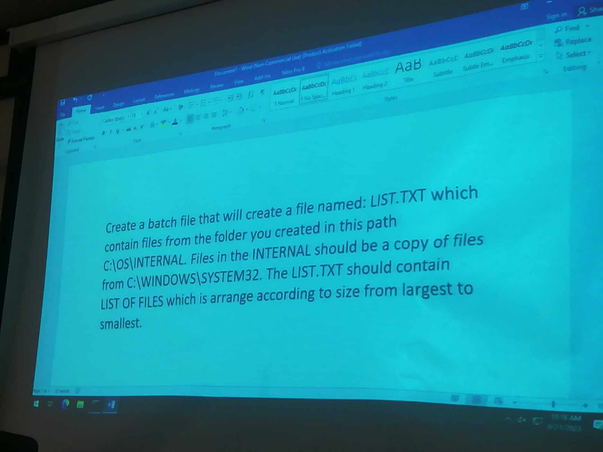

Answer

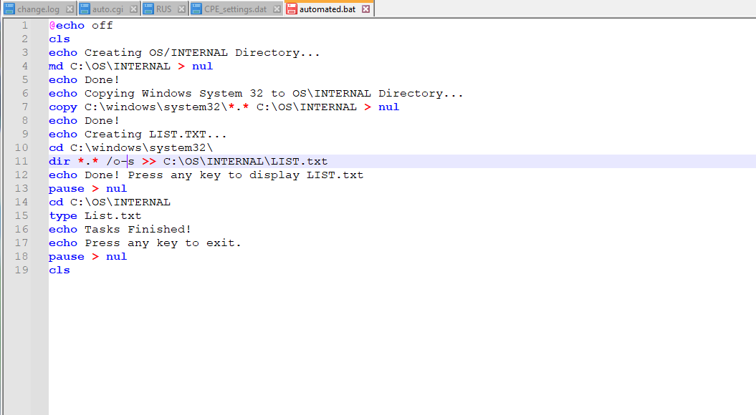

Note: echo “text” > file.docx

You can read the output using “type” but if you open on GUI ka corrupt

dir /?

Practical exam

#5

Pause:

<https://ss64.com/nt/pause.html#:~:text=Displays%20the%20message%20"Press%20any%20key%20to%20continue%20.%20.%20."&text=Execution%20of%20a%20batch%20script,key%20will%20resume%20the%20operation>.

Command < filename

**Example 1:**

cat < input.txt

This command will read the contents of the file input.txt and output them to the console.

**Example 2:**

sort < input.txt > output.txt

This command will read the contents of the file input.txt, sort them, and then output the sorted contents to the file output.txt.

**How to use Piping**

The pipe (|) operator in the Command Prompt is used to connect two commands together.

Example 1:

dir | sort

This command will list the contents of the current directory and then sort the output by name.

*C:\Windows\System32>dir b*.dll /p |sort*

*C:\Windows\System32>dir b*.dll /on |more*